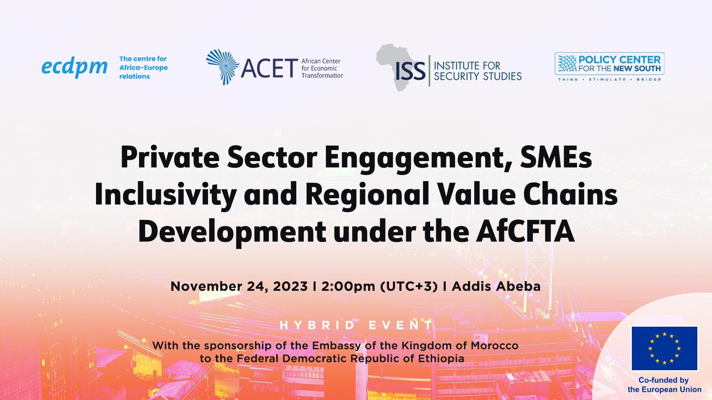
Public Event: Private Sector Engagement, SMEs Inclusivity and Regional Value Chains Development under the AfCFTA
Date and time: November 24, 2023, at 14h00 UTC+3
Location: Radisson Blu hotel + online

Background
Regional Value Chains (RVCs) play a pivotal role in driving Africa’s economic growth and development. They hold immense potential to catalyse productive transformation and enhance competitiveness, while fostering resilience in the face of global shocks. Nevertheless, despite the undeniable potential of RVCs, Africa’s current participation in the broader spectrum of GVCs remains rather modest. African producers contribute to a mere 1.7% of GVCs in 2019, a slight increase from their 1.5% participation in 2000. While this is indicative of some progress, albeit limited, it underscores the substantial room for growth and improvement. Moreover, RVCs in Africa represent only 2.7% of its GVCs participation, compared to over 26% in Latin America and the Caribbean and almost 43% in developing Asia.
Developing Regional Value Chains is a key element in operating the transition to a resilient, more competitive and economically integrated Africa and to reduce the continent’s dependency on unprocessed goods while increasing its resilience to supply chain shocks. Presently, Africa (15% of global population) represents 2.3% of world’s export. 14% of its export is intra-continental and a significant share of this intra-African trade is composed of semi-processed or processed goods.
Hence, by establishing a unified continent-wide market, alleviating intra-African trade costs, lowering barriers to investment and harmonising regulations, the AfCFTA presents a significant opportunity to strengthen RVCs integration across the continent. In particular, this all-encompassing agreement aims to eliminate the obstacles hindering the development of RVCs by addressing a wide range of barriers to the movement of goods and capital. This paves the way for the development of RVCs across various sectors including the automotive sector, agri-food (including Formulated Complementary Food for infant and younger children) and pharmaceuticals, or other industries such as clothing and textiles or eco-tourism.
In this regard, the active engagement of the private sector, a pivotal player in production, investment, and trade, is imperative for the effective implementation of the AfCFTA. This engagement must be underpinned by an inclusive approach that takes into account the specificities of the African private sector. A critical aspect of this inclusivity in the African context involves, among others, recognizing the role of Small and Medium Enterprises (SMEs), which account for 90 percent of Africa’s private sector, contributing substantially to the continent’s employment and GDP. This necessitates the development of specific and tailored policies for these companies, recognizing their unique characteristics and distinct needs compared to multinational corporations. Therefore, in order to fully harness the transformative potential of the AfCFTA, it is imperative to not only engage large corporations, although very much key in the development of RVCs, but also to create an enabling environment that empowers and supports SMEs.

Key questions
- Private Sector Engagement and SMEs Inclusivity:
- What specific gaps and obstacles do private sector stakeholders identify as barriers to their full engagement in the AfCFTA process? What key actors are best positioned to address these challenges within the AfCFTA framework?
- What incentives and policies should be implemented to encourage the private sector's proactive involvement in the AfCFTA?
- What specific challenges do SMEs encounter within the African business and trade environment? How can the AfCFTA framework be structured to ensure that SMEs inclusivity? And how does the empowerment of SMEs contribute strategically to fostering the integration into Regional Value Chains (RVCs) envisioned by the AfCFTA?

- Unpacking the potential of RVCs
- How can AfCFTA be strategically leveraged to foster the expansion and deepening of existing RVCs while simultaneously offering an allowing environment for the formation of new and dynamic value chains?
- African economies rely heavily on their imports of pharmaceutical products, with only 3 percent of their demand being met through intra-African Trade. The vulnerability of Africa’s pharmaceutical industry was starkly underscored by the disruptions in global supply chains caused by the COVID-19 pandemic, highlighting the importance of transitioning towards more regional and local supply chain. In this regard, what strategies can the AfCFTA leverage to proactively support the development of resilient regional value chains in the pharmaceutical industry? And how should it approach critical challenges, including the harmonization of regulations across Africa and intellectual property concerns?

Agenda

14h00 – 14h30 Welcoming remarks
H.E. Mr. Roland Kobia, Ambassador of the European Union to the Federal Democratic Republic of Ethiopia and the African Union
H.E. Mrs. Nezha Alaoui M’hammdi, Ambassador of the Kingdom of Morocco to the Federal Democratic Republic of Ethiopia; Senior Fellow, Policy Center for the New South
Francis Mangeni, Representative of His Excellency the Secretary General of the African Continental Free Trade Area

14h30 – 14h45 Presentation of key messages from the expert workshop
George Boateng, Senior Policy Analyst, African Center for Economic Transformation (ACET)
14h45 – 15h30 Session 1 – Empowering the African Private Sector and SMEs within the AfCFTA
The success of the AfCFTA relies on the active participation of the private sector, which plays a pivotal role in production, investment and trade across the continent. In addition, within the African landscape, where Small and Medium Enterprises (SMEs) account for 90 per cent of the private sector, a critical issue arises: ensuring an inclusive implementation of the AfCFTA as a necessary condition for tapping into the Agreement’s full potential.
This panel session is dedicated to exploring the specific challenges that private sector stakeholders face as barriers to their full engagement in the AfCFTA process. The discussion will also delve into the incentives and policies required to encourage the dynamic involvement of the private sector in AfCFTA activities. In addition, this panel also aims to examine the specific challenges faced by SMEs in the African context and discuss how the AfCFTA framework can be structured to ensure the inclusivity of this category of companies. Finally, the discussion will explore how the empowerment of SMEs strategically contributes to fostering the integration of African countries into the Regional Value Chains (RVCs) envisioned by the AfCFTA.
15h30 – 16h15 Session 2 – Strengthening Regional Value Chains and Fostering Resilience in Africa under the AfCFTA
The recent economic and geopolitical shocks and the resulting disruptions in global supply chains have raised concerns about the resilience of the latter and calls for the development of more regional value chains (RVCs). Moreover, beyond strengthening resilience against future disruptions, RVCs hold the potential of enhancing competitiveness and nurturing capacity building in African economies. In this regard, the AfCFTA emerges as an opportunity to drive the establishment and expansion of RVCs across the continent. In addition, as a major trading patner of Africa, the European Union can also play a significant role in supporting the development of RVCs through cooperation programs covering a wide range of domains including but not limited to technical assistance, investments and capacity building.
This panel session will explore how the AfCFTA can be a driving force behind the expansion and deepening of existing RVCs, while also fostering an enabling environment for the creation of new and dynamic value chains across the continent. Furthermore, participants will share insights on how to leverage the AfCFTA and EU partnerships to build resilient RVCs in Africa. Moreover, with a focus on the pharmaceutical industry, participants will also discuss the AfCFTA’s role in facilitating the transition towards regional and local supply chains in this sector, ensuring the continent's readiness for future disruptions and bolstering its self-reliance.
Moderator:
Bruce Byiers, Head of African Economic Integration, ECDPM
Panellists:
- Larabi Jaïdi, Senior Fellow, Policy Center for the New South (PCNS)
- Wincate Muthini, Senior Programme Manager, PACCI
- Stephen Karangizi, Former Director and CEO African Legal Support Facility and Former Deputy Secretary General (Programmes) for COMESA
- Dirk Willem te Velde, Director, Overseas Development Institute (ODI)

16h15 – 16h30 Concluding remarks
Thomas Huyghebaert, Head of Policy and Cooperation, Delegation of the European Union to the African Union
16h30 – 17h30 Reception

Please register using this FORM

AUC/OECD (2022), “Africa’s Development Dynamics 2022: Regional Value Chains for a Sustainable Recovery”.
UN Economic Commission for Africa. https://au.int/pt/node/41140#:~:text=Further%2C%20Small%20Medium%20Enterprise%20(SMEs,UN%20Economic%20Commission%20for%20Africa.
L. Signé, C. Munyati (2023), “In Africa’s free trade area, investment in pharmaceuticals means impact and profit”. World Economic Forum.

